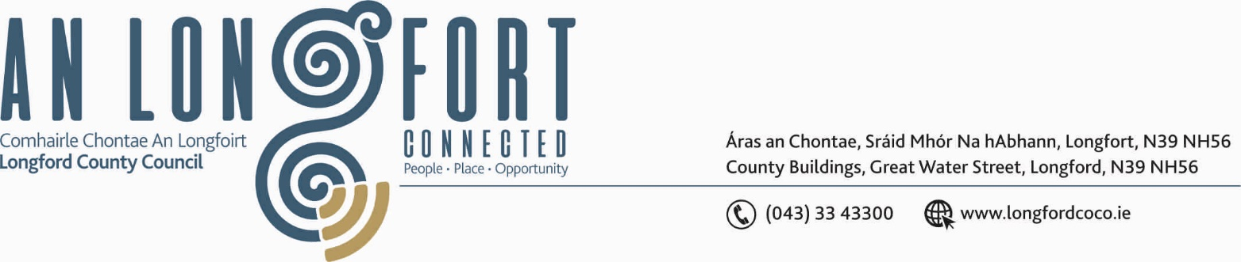

LONGFORD MUNICIPAL DISTRICT

19th September 2018.

To: Each Member of Longford Municipal District.

Dear Member,

You are requested to attend Meeting of Longford Municipal District to be held in the Council Chamber, Town Hall, Market Square, Longford, on Wednesday,
26th September 2018 at 4.00 p.m. to transact business, as set out on the Agenda hereunder.

Yours sincerely,


_______________
Anne Lee,
Meetings Administrator.

AGENDA

Prayer before meeting.

- Confirmation of Minutes of the following meetings of Longford Municipal District held on the 27th June 2018 – copies enclosed.

(i) Annual Meeting.
(ii) Monthly Meeting.
(iii) Committee Meeting.

2. Matters arising from Minutes.

- Management Report - to follow.
- Footpaths Rehabilitation Programme
- Right of way Dun Darrach/Ardnacassa.

- Presentation by IT personnel regarding Longford Town Community CCTV Signage.

5. Presentation by IT personnel and Magnet Networks on Town WIFI for Longford Town.

- Upgrade of Amenities.

- Visit by the Mayor and delegation from Noyal for the official switching on of the
2018 Christmas Lights.

- Consideration of the Longford Town (Coach and Disabled Parking) Draft Bye-Laws 2017 –report enclosed.

9. Notices of Motions submitted by Councillors, as listed hereunder –

Councillor Joe Flaherty.

“I call on IDA Ireland to immediately source a strategic land bank in the Longford town area that will enable them to market the town to major Pharma / ICT company

“In conjunction with Longford Comhaltas and other community and business organisations commence the process of targeting to stage the All Ireland Fleadh in Longford town.”

Councillor Mae Sexton.

“In the interest of clarity, that our Bye-Laws be amended to ensure that the space/s provided for the charging of electric vehicles are exempt from parking charges.”

“That we immediately review our signage and enforcement in relation to heavy duty traffic going through Teffia Park where I propose the installation of CCTV as a way of enforcing the policy”.

“That we immediately review the safety features and road condition of Cartron Road, Lisbrack between the Rugby Club and Treatment Plant.”

Councillor Gerry Warnock.

“I am calling on Longford Municipal District to complete the stretch of footpath directly opposite Longford Garden Centre servicing 53-59 Foynes Court as a matter of urgency. A number of years ago the Council completed path works from the junction of the R198 and wrapped around Knockmartin Lane but even though kerbing was installed all the way down, the path itself ceased just before No. 53. The completion of the path would be of minimal cost (as it’s a short stretch and kerbing is already installed) but it would eliminate an obvious trip/public safety hazard and improve the aesthetics of the area.”

“I am proposing that the works outlined in an LIS application for the L5028 at Creenagh, Longford be progressed as a matter of urgency. This odyssey has been going on for over three years and notwithstanding the Government Moratorium on LIS Schemes, I have previously got assurances that the job would get prioritisation following the reinstatement of the scheme. This road services a substantial number of residential properties and its current condition represents a significant public safety concern.”

Councillor Seamus Butler.

“That Longford Municipal District agrees to waive parking fees for up to four hours for electric vehicles charging at its electric charging points, and that it erects clear signage at these points to that effect.”

Councillor John Browne.

“I call on Longford County Council to have Christmas Lights erected on Killashee Street for Christmas 2018.”

:::::::::::::::::::::::::::

